**1. select first 5 rows of the "CustomerName" and "City" columns from the "Customers" table**

SELECT CustomerName, City FROM Customers LIMIT 5;

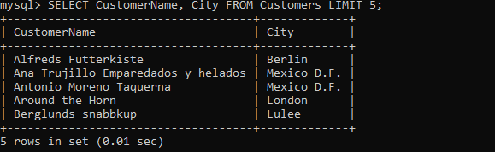

**2. select all the customers (their name and country name) from the country "Mexico"**

SELECT CustomerName, Country FROM Customers WHERE Country ="Mexico";

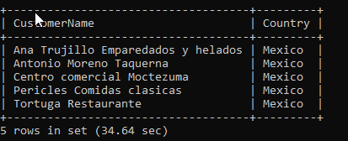

**3. select all customers' records from the country "Germany" and the city "Berlin" or "Mannheim", sort by the Address from Z to A**

Select * from Customers where Country="Germany" AND City IN ("Berlin", "Mannheim") ORDER BY Address desc;

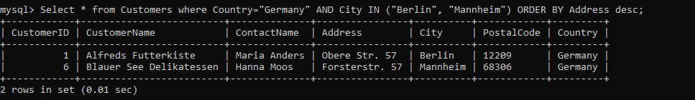

**4. select all customers' records, whose name ends with "s", from country, which name does not contain the pattern "land" and starts with "b", sort by the Country from A to Z**

Select *FROM Customers where CustomerName Like "%s" and Country NOT Like "%land%" and Country NOT Like "b%" ORDER BY Country;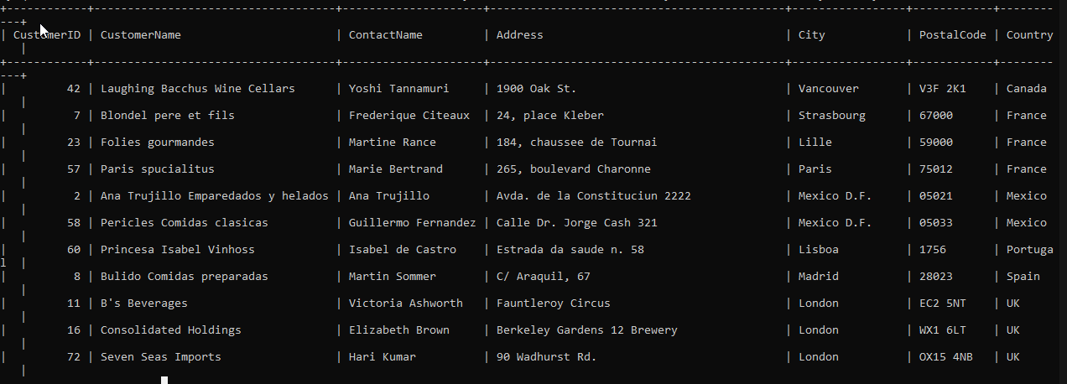

**5. select all customers' records from a City of "Paris", "Berlin", "Mannheim" or "London" and their IDs grater than 10, but less that 20**

mysql> Select * FROM Customers where City IN ("Paris", "Berlin", "Mannheim", "London") and CustomerID BETWEEN 11 and 19;

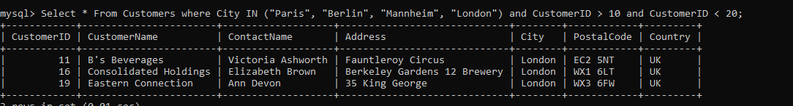

**6. selects all orders with an ordered between 04-July-1996 and 09-July-1996**

Select * FROM Orders where OrderDate BETWEEN '1996-07-04' AND '1996-07-09';

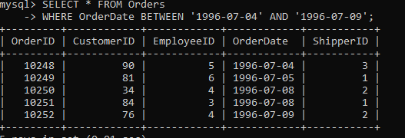

**7. select the list of orders (its ID, customer's Name and the date of an order) which were made in the second decade of February, 1997**

Select Orders.OrderID, Customers.CustomerName, Orders.OrderDate from Orders Join Customers ON Orders.CustomerID = Customers.CustomerID and Orders.OrderDate between '1997-02-11' and '1997-02-20';

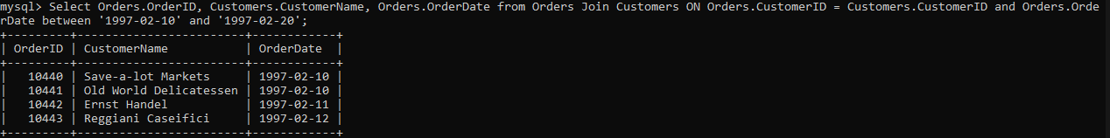

**8. find all employees (their names) and "Amount of orders" they made (if any), sort them by name from A to Z, ensure all result columns have appropriate names. (use GROUP BY)**

Select Employees.FirstName, count(Orders.OrderID) as "Amount of Orders" from Employees left outer join Orders on Orders.EmployeeID=Employees.EmployeeID group by Employees.FirstName;

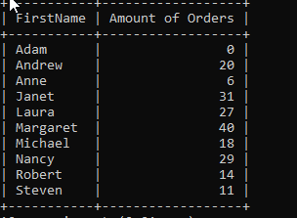

**9. select all unique UK cities, where customers and suppliers live, sort from A to Z (use UNION)**

Select Distinct City from Customers where Country ="UK" union select Distinct city from Suppliers Where Country = "UK" ORDER BY City;

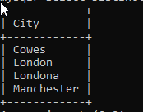

**10.select products (their names) and prices records that have an above average price, but cheaper than 33, sort ascending**

Select ProductName, Price From Products where Price>(select avg(Price) from Products) and Price < 33;

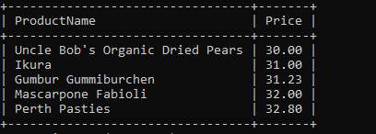

**11.Найти товары с максимальной ценой.**

mysql> Select ProductName, Price From Products Where Price = (Select (max(price)) From Products);

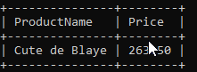

**12.Вывести сумму всех товаров, в названии которых содержится ”od”, столбец назвать Summ.**

Select SUM(Price) AS SUMM From Products where ProductName Like "%od%";

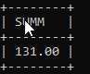

**13.Вывести среднюю сумму товаров, поставляемых в бутылках, округлив до 2-х знаков после запятой, столбец назвать Round Sum. (используйте функцию ROUND)**

Select round(AVG(Unit),2) AS RoundSum From Products where Unit Like "%bottl%";

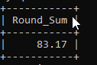

**14.Выбрать все товары, у которых поставщик «Grandma Kelly's Homestead» и цена > 27. В результате вывести 3 колонки: Product, Supplier, Price.**

Select Suppliers.SupplierName AS Supplier, Products.ProductName as Product, Products.Price From Suppliers join Products on Suppliers.SupplierID = Products.SupplierID Where Suppliers.SupplierName = "Grandma Kelly's Homestead" and Price>27;

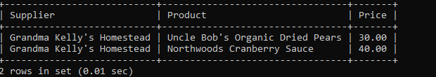

**15.Найти количество клиентов, которые НЕ проживают в Франции и Германии, столбец назвать Not Count.**

Select Count(CustomerID) as NotCount From Customers where Country NOT In ("Germany", "France");

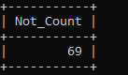

**16.Показать имена товаров, в названии которых третяя буква m и названия их поставщиков.**

Select Products.ProductName, Suppliers.SupplierName From Products Join Suppliers on Products.SupplierID = Suppliers.SupplierID where ProductName Like "__m%";

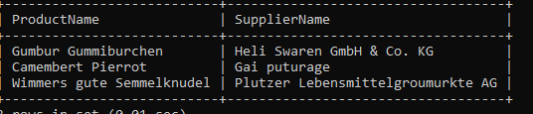

**17.*** Вывести суммарное количество продукта 'Queso Cabrales' (столбец обозвать Summ), отправленного всем покупателям (написать запрос двумя способами: через INNER Join, и используя подзапрос).**

Select SUM(OrderDetails.Quantity) as SUMM From OrderDetails join Products on OrderDetails.ProductID=Products.ProductID where ProductName like "Queso Cabrales";

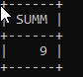

**18. *** Показать все продукты, содержащиеся в заказах 1997-го года и в названии которых менее 5 букв. В результате вывести OrderID, OrderDate, ProductName (написать запрос двумя способами: через INNER JOINS, и используя подзапросы).**

Select OrderDetails.OrderID, Products.ProductName, Orders.OrderDate From OrderDetails join Products on OrderDetails.ProductID=Products.ProductID join Orders on OrderDetails.OrderID=Orders.OrderID where OrderDate like "1997-%-%" and length(ProductName)<5;

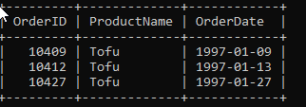

**19. *** Показать все заказы, которые были отправлены по адресу «Ekergatan 24» с их заказчиками и сотрудниками. В результате вывести 3 колонки – ID заказа, имя заказчика, имя сотрудника, фамилия сотрудника.**

Select Orders.OrderID, Customers.CustomerName, Employees.FirstName, Employees.LastName from Orders join Customers on Orders.CustomerID=Customers.CustomerID join Employees on Orders.EmployeeID=Employees.EmployeeID where Address ="Ekergatan 24";

